Eternal Universe
Karim Khaidarov
e-mail karim@mail.kz http://bourabai.narod.ru/
Dedicated to the bright memory of my daughter Anastasia. August 1, 2003
In December of 1998, there was published a seminal work using precise measurements of supernovae magnitudes and leading to the conclusion of an apparent accelerated expansion of observed part of Universe. But when we approach the processing of these precise data from a classical ethereal position, without relativistic adjustments, we get another picture, and we believe it is the correct one. It is presented in this paper.

Introduction
Let us begin with two contrasting quotes: 1) “And so, cosmology has gained the real status of a respectable science. It already has splendid results, forming hard foundation, which will remain forever. Theory of "Big Bang" has such a status.” Ya. B. Zeldovich; 2) “There is nothing eternal, alas, except eternity.” Paul Fort
In December of 1998, a seminal work using precise measurements of supernovae magnitudes was published by S. Perlmutter et al.. [1] This work was elaborated within the framework of the “Supernova Cosmology Project” by using data of the “Calan/Tololo Supernova Survey”. Its main cosmological conclusion consisted of an apparent accelerated expansion of observed part of Universe. This conclusion is noteworthy because it disagrees with each of three variants of the reigning Einstein-Freedman Universe Model.
The present author has used supernovae data from [1], and taken as a basis the classical idea that there exists of universally present substance – ether – that is the carrier of EM-field waves, and that subjects such waves to constant fading, just like waves in the usual isotropic physical media: solids, liquids, gasses.
In this case, energy of quanta of EM-radiation will follow a function of time (see a good review of this approach in [2]):
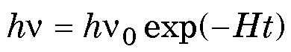 (1)
Here 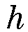 is Planck’s constant, 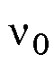 is the original quantum frequency, 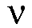 is the quantum frequency after time , 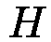 is the Hubble constant (the factor of ether absorption), and is the time between emission and reception.
The definition of redshift parameter is:
Z = 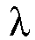/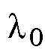-1 = /-1 (2)
where is the wavelength of received light, is the wavelength radiated, is the frequency of received light, and is frequency of the radiated light.
From (1) and (2) we get the dependency of upon :
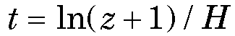 (3)
In these terms, it is possible to calculate normalized peak power of supernova radiation:
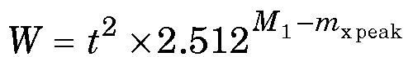
where is time [ 10⁹ years], 2.512 is the base of the star luminosity scale, 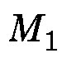 is the supernova luminosity, extrapolated to 1 billion light years, and 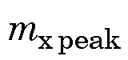 is the observed supernova peak luminosity.
This author reviewed data from [1] and found pinpoint accuracy for its correspondence to Eq. (1). Average absolute Type Ia supernovae luminosity is determined by:
M_{0 aver} = M₁ – 2.5 lg(10⁸/3.263)² = -18.5
The supernovae distribution on the time scale (3) using sample [1] is shown on Fig. 1. (For source data, see http://bourabai. narod.ru/table_1e.htm.) To reduce data dispersion for small , a correction for the velocity of the observer with respect to the Cosmic Microwave Background is made. This velocity is taken as 390 km/s, or 0.0013 of the light velocity.
For more exact checking, Eq. (1) data on Type Ia supernovae from different catalogues from 1973 to 2003 were examined [3]. If the value of 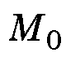 differed from the earlier received average by no more than on 0.8 luminosity unit, it was included for further processing. If the redshift of supernova were not indicated, it was restored from relativistic ‘redshift (Doppler effect) velocity’. As a result, the distribution shown on Fig. 2 was constructed (For source data, see http://bourabai.narod.ru/table_2e.htm.)
Unlike data in [1], catalogue data are not so precise, and the dispersion of their distribution is higher. However, the estimate of average differs from that of the first sample by only 0.182. The correctness of statistics of the sample used is seen from the histogram shown on Fig. 3.

From the results of this data processing, it was determined that the most ancient supernova 1995bf (Gal-Yam, Sharon, Maoz) has the age 25.910⁹ years. That is to say, its age is nearly two times more than the presumed age of the ‘relativistic’ Universe. (This supernova is unique in its remoteness, which is not clearly revealed by relationships on Fig. 2.)

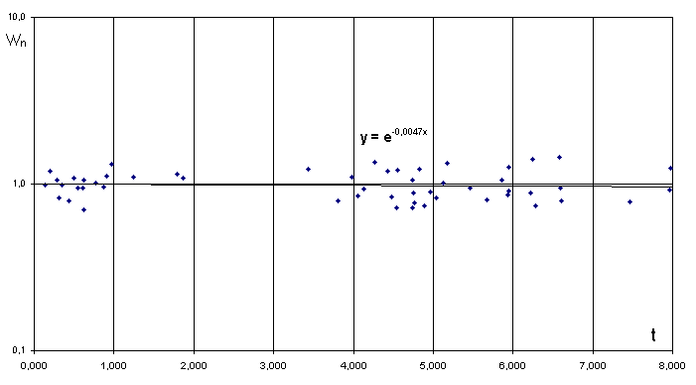
Fig.1. Distribution of 52 supernovae on non-relativistic time scale [10⁶ years] for H = 72 km/sMps (fading of light already substracted from data).
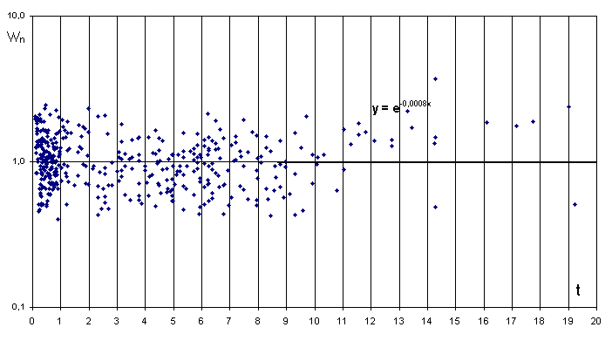
Fig.2. Distribution of 433 supernovae on non-relativistic time scale [10⁹ years] for H = 72 km/sMps (fading of light already subtracted from data).

Histograms of supernovae distribution in time and supernovae normalized frequency by volume within the observed part of Universe are shown on Fig. 4. The distribution of supernovae frequency shows that 6-7·10⁹ years ago, the intensity of supernovae origin decreased exponentially. So in our galaxy and nearby galaxies, the intensities of supernovae cores are lower than observed in the distant cosmos.

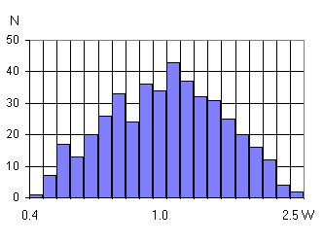
Fig. 3. Histogram of supernovae amount distribution on energy in sample.
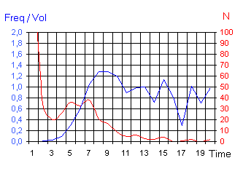
Fig.4. Distribution of supernovae amount (declining curve) on time descending to the past and distribution of supernovae frequency, observed in the Universe as functions of time into the past, measured in units [10⁹ years] (rising curve).

Conclusions
From this study, we can draw following conclusions:
• With the exponential increase the wavelength of light and the presence of ether with 2.73 ⁰K temperature (Cosmic Microwave Background, CMB), different celestial bodies each have their own horizons of visibility:
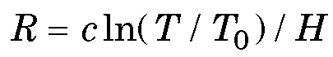
where is the speed of light in vacuum, 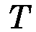 is the temperature of the radiation of the observed celestial body, is the Hubble constant, 72 [km / s Mps], and 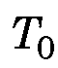 is the temperature of ether, 2.73 ⁰K.
• So, for stars having 6000 ⁰K surface temperature, this horizon has following value:
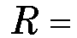 13.6 ln(6000/2.73) = 105 [10⁹ years]
According to this formula, the CMB is formed ‘locally’; that is to say, not hereinafter plus or minus 500 megaparsec. This conclusion has confirmed the recent studies of correlations of x-ray sources with Cosmic Microwave Background [4].
• Being proportional to the logarithm of frequency, the Horizon for high-energy quanta, such as those in x-rays and gamma-rays, must be greatly enlarged.
• The model offered does not need any hypothesis of a Big Bang and subsequent ‘expansion’ of the Universe. It does not require a relativistic Doppler effect, the absence of which in the Solar system was shown 40 years ago, in 1961, during radar measurements of Venus surface [5, 6].
• In the model offered, there is no conflict between the age of the Universe and the age of ancient formations in the cosmos.
• In the model offered, there is no ‘photometric paradox’, since EM-radiation is absorbed by the ether – i.e., by the ‘physical vacuum’. However, some mechanism for ultimate disposal of ether energy is necessary to preserve a stable temperature of 2.73 ⁰K. We do not know that disposal mechanism. Possibly, it is a process of spontaneous birth of elementary particles within localities of increased temperature in the ether [7].
• Since Eq. (1) and its correspondence to the distribution of supernovae are invariant for any value of Hubble constant, known at present time only approximately, it will remain equally valid after any future revision of the cosmic distance scale.

Acknowledgment
The author thanks Valery V. Petrov for his corrections, which have improved this presentation.
The author thanks Dr. Cynthia Kolb Whitney and Daniel Whitney for important help with English version of this article.

References
[ 1 ] S. Perlmutter et al., “Measurements of Ω and Λ from 42 high-redshift supernovae”, The Astrophysical Journal 517, 565-86 (1999).
[ 2 ] A.K.T. Assis & M.C.D. Neves, “The Redshift Revisited”, Astrophysics & Space Science 227, 13-24 (1995).
[ 3 ] D. Yu. Tsvetkov, N. N. Pavlyuk, O. S. Bartunov, Yu. P. Pskovskii, The Sternberg Supernova Catalogue – 2003, – available on http://www.sai.msu.su/sn/.
[ 4 ] S. Boughn & R. Crittenden, “A correlation of the cosmic microwave sky with large scale structure”, –ICG-03-08, May 2003, 8 pp, available on e-Print Archive: http://arxiv.org/abs/astro-ph/ .
[ 5 ] V.A. Kotelnikov, “Radar installation using during Venus flexing in 1961”, Radiotekhnika i elektronika 7 (11) 1851 (Moscow, 1962).
[ 6 ] V.A. Kotelnikov, et al., Results Venus radar flexing in 1961, Radiotekhnika i elektronika 7 (11) 1860 (Moscow, 1962).
[ 7 ] V.F. Shipitsin, A.A. Zhivodiorov, L.G. Gorbich, Hypothesis of the Space Structure (Ural State Univer. Publishers, Yekaterinbourg, 1996).

Three types of Einstein-Freedman’s Model are options with 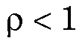 (eternally expanding Universe), 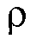=1 (expanding to stationary) and >1 (expanding , then shrinking). is normalized density of Universe.
390±30 km/s velocity is average value of different authors measurement of absolute Earth’s motion in the ether. Besides Cosmic Microwave Background anisotropy, which Space-oriented frequency changing corresponds to that velocity, there are measurements of light group velocity changing made by D.G. Torr and P. Kolen [Natl. Bur. Stand. (U.S.), Spec. Publ. 617, 1984], prof. St. Marinov [Austria, 1987] and others.

